Project Iteration 2

CSE 6324: Advanced Topics in Software Engineering

Project Name : [Shape Recipe](https://github.com/utastudents/ShapeRecipe)

**Team 1**

Harsh Chaludia

Deep Patel

Abstract:

**A. Planning:**

1. Features
2. Planning
3. Similar related apps in the market
4. How we differ from similar apps in the market.
5. Five biggest risks in terms of time constrain.
6. Plans to deal with risks.

**B. Specification & Design:**

1. Inputs and Outputs
2. Data structures
3. Use-cases

**C. Code & Tests:**

1. Code snippets
2. Test cases
3. Instruction to compile and run the code
4. UI Layout

**D. Customers & Users:**

1. Who are the customers and their needs
2. Customer Feedback

**E. Reference:**

**A. Planning**

**1. Features:**

We load the image file with a resized factor typically smaller, to outline the shapes with a good estimation. Next, we grayscale the image, to find contours then we grab the contours, and finally initialize the shape detector.py, and label the images. After that we create a JSON object with shapes, and dump it on PHP page, or a server to decode it with an array. After that we Map each object with skeleton elements like header, footer, cards, slider etc. Finally, getting the json object we generate a website, or a react native app which renders the app both on IOS as well as android.

**2. Planning:**

We have decided to use EXPO which is an native app framework – opensource. This will help us to render the application to both in android as well as IOS. Secondly, we will be having instruction manual for sketches to help in deciding the design for the website.

**3. Similar related apps in the market:**

1. Fronty (<https://fronty.com)>

Fronty is a paid application which takes an image as an input from the from user and converts that image into an HTML website and also gives the facility to make the website live. So it is required that the uploaded image is fully designed website photoshop image. The app then converts the image to HTML website. It provides the facility to manual change the content of the website before it is published. Finally, if the user is satisfied with the website converted, then he/she publishes the website which is also one of the feature of the app to publish directly from the app.

2. Sketch-code (<https://github.com/ashnkumar/sketch-code>)

Sketch-code is an open source project Ashwin Kumar(<https://github.com/ashnkumar>) which converts the hand drawn wireframe of the website to generate HTML markup. So the app scans the image provided by the user and then with help of their AI model it identifies text and shapes in the image. Finally, once the shapes are recognized the shapes are converted into HTML elements like div and button.

**4. How we differ from similar apps in the market:**

1. Fronty (<https://fronty.com)>

Fronty is a strong competitor for our app in the market. However, there are quite distinguishing features in our app which gives us the upper hand in comparison to fronty. Firstly, we have a manual of shapes that are associated with code, so user need not need a high photoshop image made by a professional UI/UX developer. Secondly, we have 2 options to choose from for the final code either website or the mobile application UI.

1. Sketch-code (<https://github.com/ashnkumar/sketch-code>)

Sketch-code basic idea seems to match with our overall idea of hand drawn images. However, Sketch-code app is still in research phase and doesn’t give market useable product /fully developed website code. Moreover, it uses the AI model which separates every element in the image not just limited to proper shapes but to text and other uneven shapes while we are associating code with the shapes.

**5. Five biggest risks in terms of time constraint:**

Risk 1: Considering the edge detection method, it could be a tedious task if we draw with a doodle element where the sketch could slightly change the polygons. So, we give a probability of 70% for this scenario and 15 hour effect which gives the risk effect of 10.5 hours for this risk.

Risk 2: To render the application on React Native platform, we need to save the results/ outcome in an API call to save progress. So, we give a probability of 60% for this scenario and 12 hour effect which gives the risk effect of 7.2 hours for this risk.

Risk 3: Without knowing instructions to sketching, would confuse the users, and they might end up making an incorrect version of their design. So, we give a probability of 50% for this scenario and 8 hour effect which gives the risk effect of 4 hours for this risk.

Risk 4: We observed, we only took shapes as the method to draw elements like footer, header, etc. This limited us to include limited elements. So, we give a probability of 60% for this scenario and 15 hour effect which gives the risk effect of 9 hours for this risk.

Risk 5: For mobile, Xcode, and android studio is already into drag & drop. So, we give a probability of 40% for this scenario and 10 hour effect which gives the risk effect of 4 hours for this risk.

**6. Plans to deal with risks:**

Risk 1: To overcome this issue, we can ask the user to drag and drop shapes from the toolbar, to approximate the shapes.

Risk 2: We need to have a temporary database, and the ideal solution would be using NoSQL database.

Risk 3: We can make an instruction manual in a separate page on the website.

Risk 4: We decided to use more colors to also have styling of elements associated to geometric shapes. Also, we are planning to have numeric digits to have more choices for users.

Risk 5: To avoid already existing features, and since we are using React Native, we will incorporate themes made by open source theme providers.

**B. Specifications & Design**

**1. Inputs and Outputs:**

The input for our app will be an image of either hand drawn sketch of shapes or drawn using some drawing tools like paint or photoshop and the output will an website along with it’s source code.

Input:

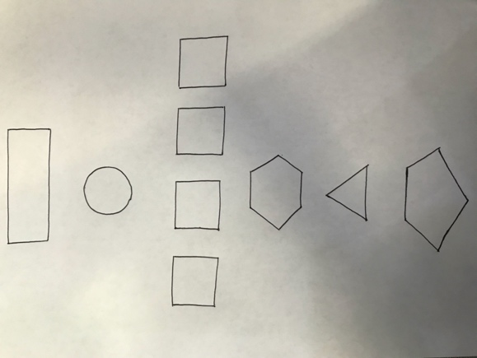 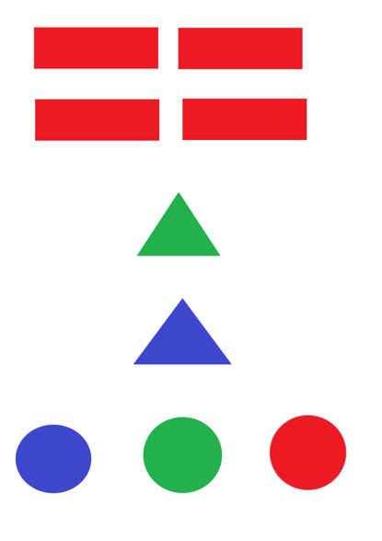

Hand drawn sketch Sketch drawn in MS Paint

Output:

[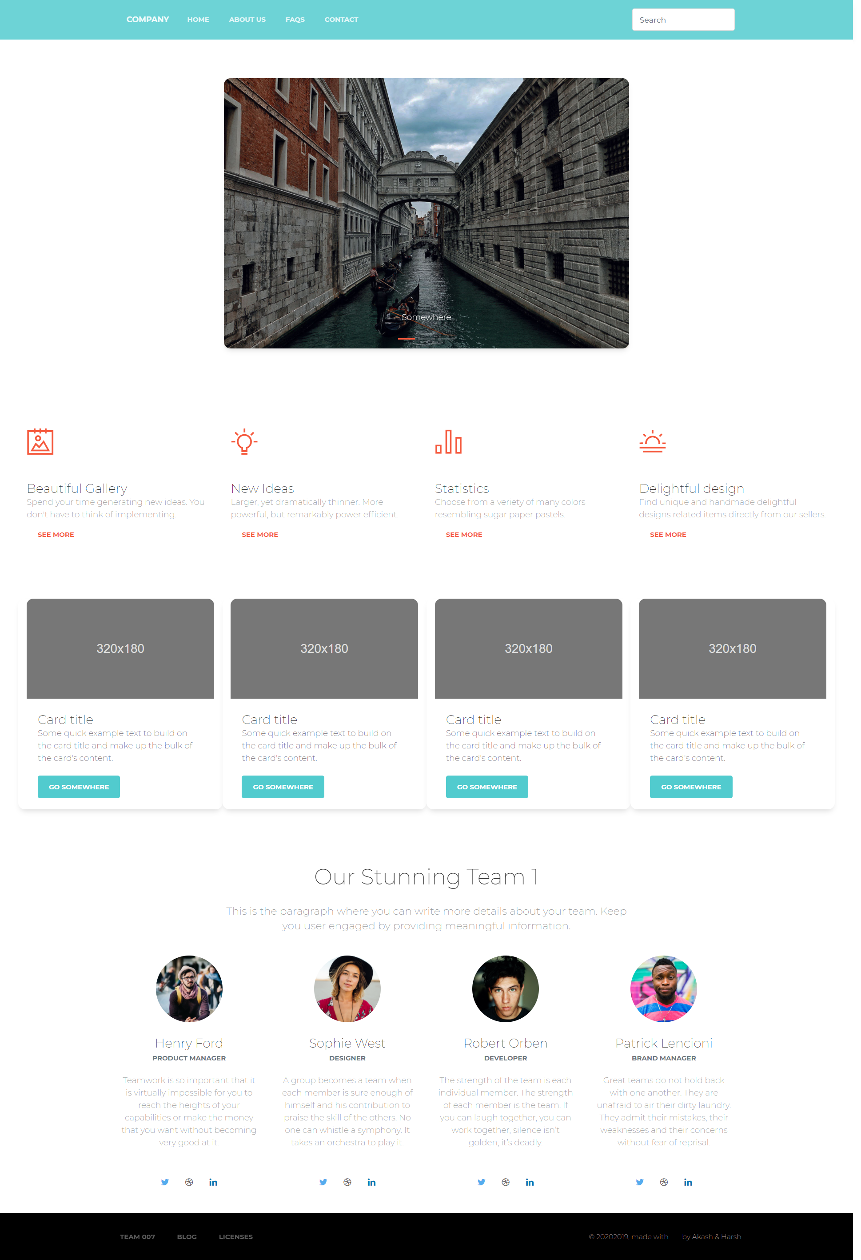](https://mavsuta-my.sharepoint.com/personal/deepbipinbhai_patel_mavs_uta_edu/_layouts/15/onedrive.aspx?id=%2Fpersonal%2Fdeepbipinbhai%5Fpatel%5Fmavs%5Futa%5Fedu%2FDocuments%2FCSE6324%2FIteration%201%2FFlow%20diagram%20images%2Fscreencapture%2Dfile%2DC%2Dxampp%2Dhtdocs%2Dsketch%2Dhtml%2Dtest%2Dhtml%2D2020%2D09%2D28%2D22%5F24%5F12%2Epng&parent=%2Fpersonal%2Fdeepbipinbhai%5Fpatel%5Fmavs%5Futa%5Fedu%2FDocuments%2FCSE6324%2FIteration%201%2FFlow%20diagram%20images)

Website(Image clickable)

**2. Data structures:**

We are using Pandas Library for managing the data which we got after identifying either shapes, color or numbers from the sketch image. For now, we have 6x6 grid for shapes that can we drawn i.e. 6 shapes at max in rows and columns. And once this values are identified correctly then they are managed in the matrix. In the end, code is appended iteratively in the final website which is mapped with the values of each cell in the matrix. The code will stored in the JSON format and this JSON will be called every time we need to do the mapping of elements.

**3. Use Cases:**

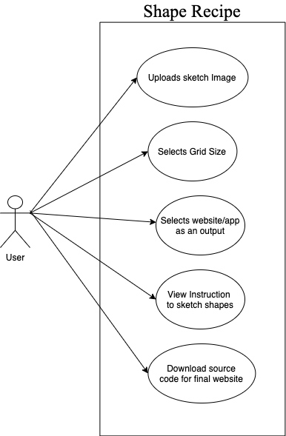 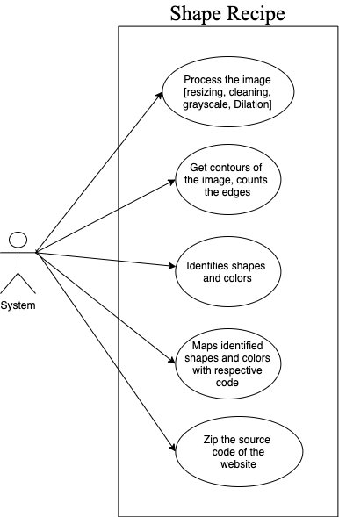

Use case diagrams

[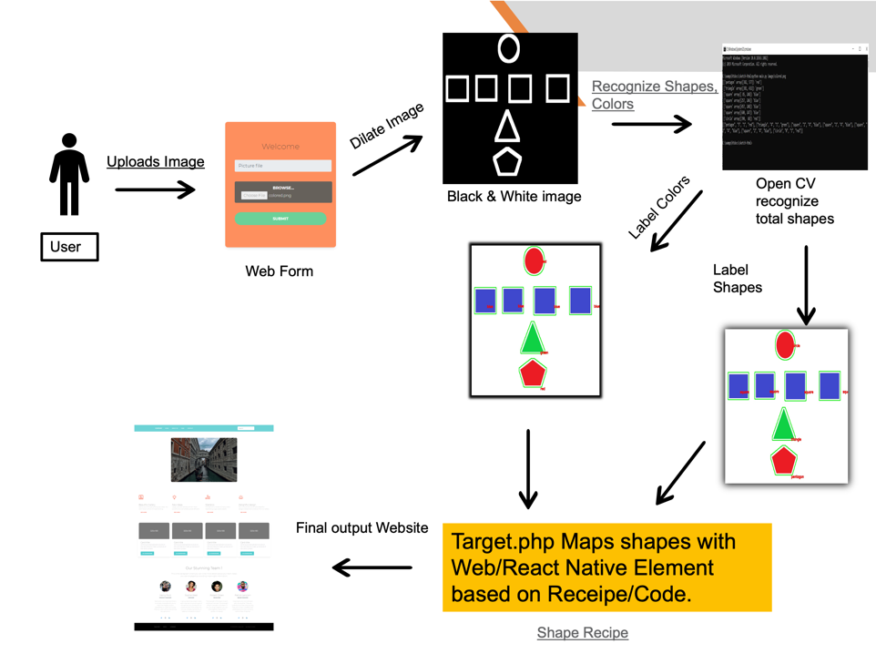](https://mavsuta-my.sharepoint.com/:i:/r/personal/deepbipinbhai_patel_mavs_uta_edu/Documents/CSE6324/Iteration%202/Screen%20Shot%202020-10-20%20at%2012.49.55%20AM.png?csf=1&web=1&e=dzA9yX)

As per the rubric, along with use case diagram we are also providing here screen shot transition diagram

**C. Code & Tests**

**1. Code snippets:**

# **Main Function**– Detect Shapes, and Colors from the input image.

    # Read the image data from argument

    image = cv2.imread(argv[1])

    # Resize if it is necessary(faster but not accurate)

    resized = imutils.resize(image, width=800)

    ratio = image.shape[0] / float(resized.shape[0])

    blurred = cv2.GaussianBlur(resized, (5, 5), 0)

    gray = cv2.cvtColor(blurred, cv2.COLOR_BGR2GRAY)

    lab = cv2.cvtColor(blurred, cv2.COLOR_BGR2LAB)

    thresh = cv2.threshold(gray, 60, 255, cv2.THRESH_BINARY)[1]

    # Get the edge by canny effect

    canny = cv2.Canny(gray.copy 80, 120)

    # Set the kernel for dilation(make the white line thicker)

    kernel = np.ones((3, 3), np.uint8)

    dilation = cv2.dilate(canny.copy(), kernel, iterations=7)

    cv2.imwrite('dilate.jpg', dilation)

    # Get the contour from dilated picture, EXTERNAL contour used

    cnts = cv2.findContours(dilation.copy(), cv2.RETR_EXTERNAL,cv2.CHAIN_APPROX_NONE)

    cnts = imutils.grab_contours(cnts)

    # ColorLabel

    # initialize the ShapeDetector class

    sd = ShapeDetector()

    cl = ColorLabeler()

    oracle = []

    for c in cnts:

        try:

            # Do if the contourarea is larger than specific area

            if cv2.contourArea(c) > np.shape(image)[0] / 40 * np.shape(image)[1] / 40:

                # Get the moments of the shapes

                M = cv2.moments(c)

                cX = int(M['m10'] / M['m00'])

                cY = int(M['m01'] / M['m00'])

                # Detect the shape

                shape = sd.detect(c)

                color = cl.label(lab, c)

                # Put additional information in the image

                c = c.astype('float')

                c *= ratio

                c = c.astype('int')

                cv2.drawContours(image, [c], -1, (0, 255, 0), 2)

                cv2.putText(image,shape,(cX, cY),cv2.FONT_HERSHEY_SIMPLEX,0.5,(0, 0, 255),2,)

                # Store the shape information to oracle

                oracle.append([shape, np.array([cX, cY]),color])

        except:

            continue

    # Save the image file

    cv2.imwrite('Shape_recognized.jpg', image)

    alsoOracle = oracle

    oracle = np.array(oracle)

    #print(oracle)

    # Create the json file to return the following value to PHP

    # ["Type of shape", "RowID", "number of shape in the same row"]

    jsonfile = get_block(image, oracle, (6, 6),alsoOracle)

    print(jsonfile)

# **Get Block Function**-- "Type of shape", "RowID", "Total shapes in row", ”Color”

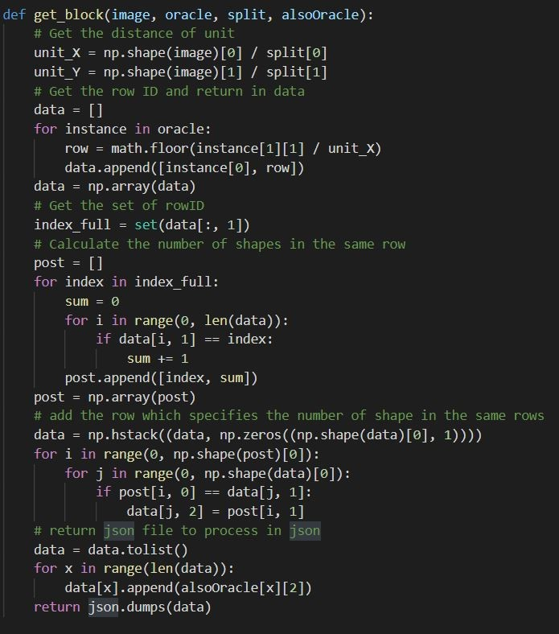

# **Shape Detection Function**– Using Ramer-Douglas-Puecker algorithm using approxPolyDp function from cv2, and edge detection method.

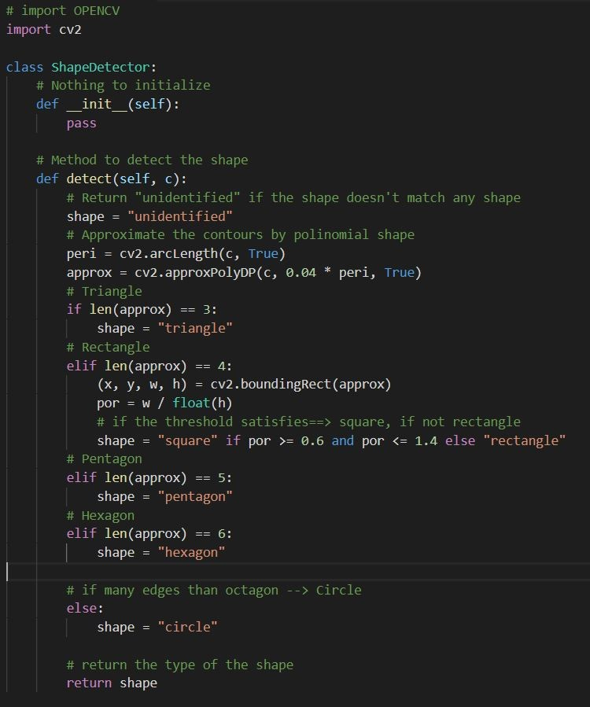

# **Color Detection Function**– Using Lab Color Space, by converting RGB values to (L*,a*,b*)

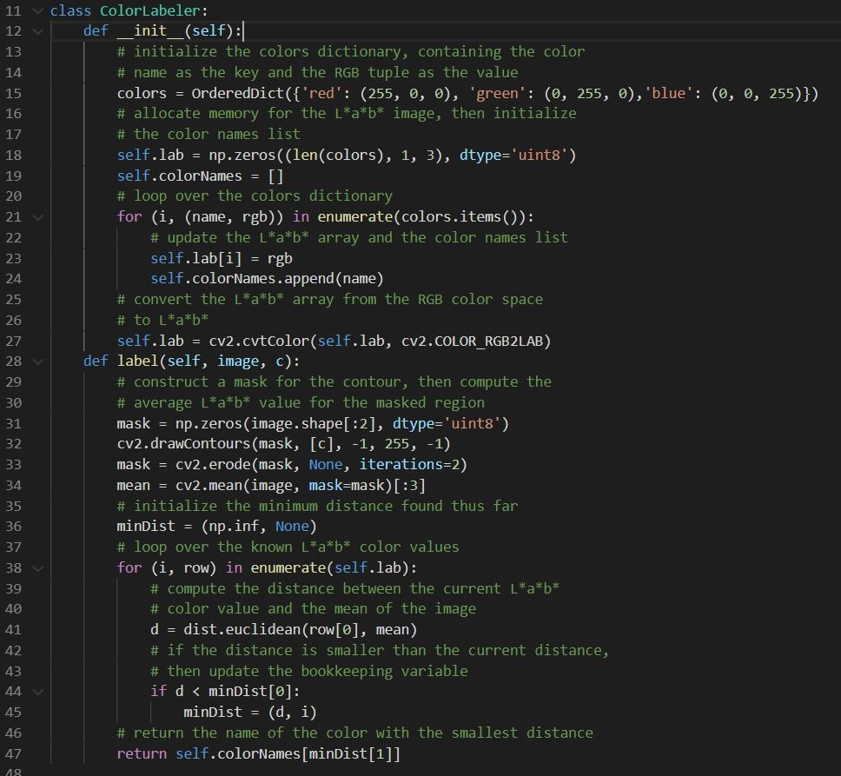

**2. Test cases:**

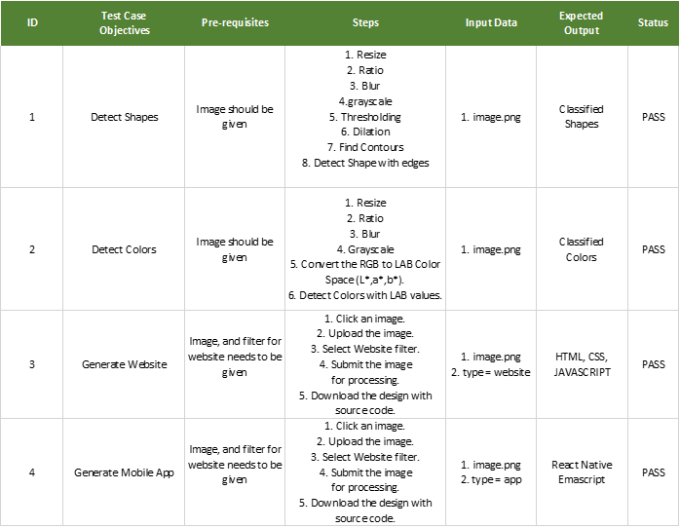

**3. Instruction to compile and run the code:**

Getting the files

git clone https://github.com/utastudents/ShapeRecipe.git

Choose an image or Sketch one.

1. Upload an image, or sketch with shapes.
2. Submit the image for processing.
3. Run it over a localhost.

Prerequisites

* Python 3 (not compatible with python 2)
* pip
* Php

**4. UI Layout:**

**[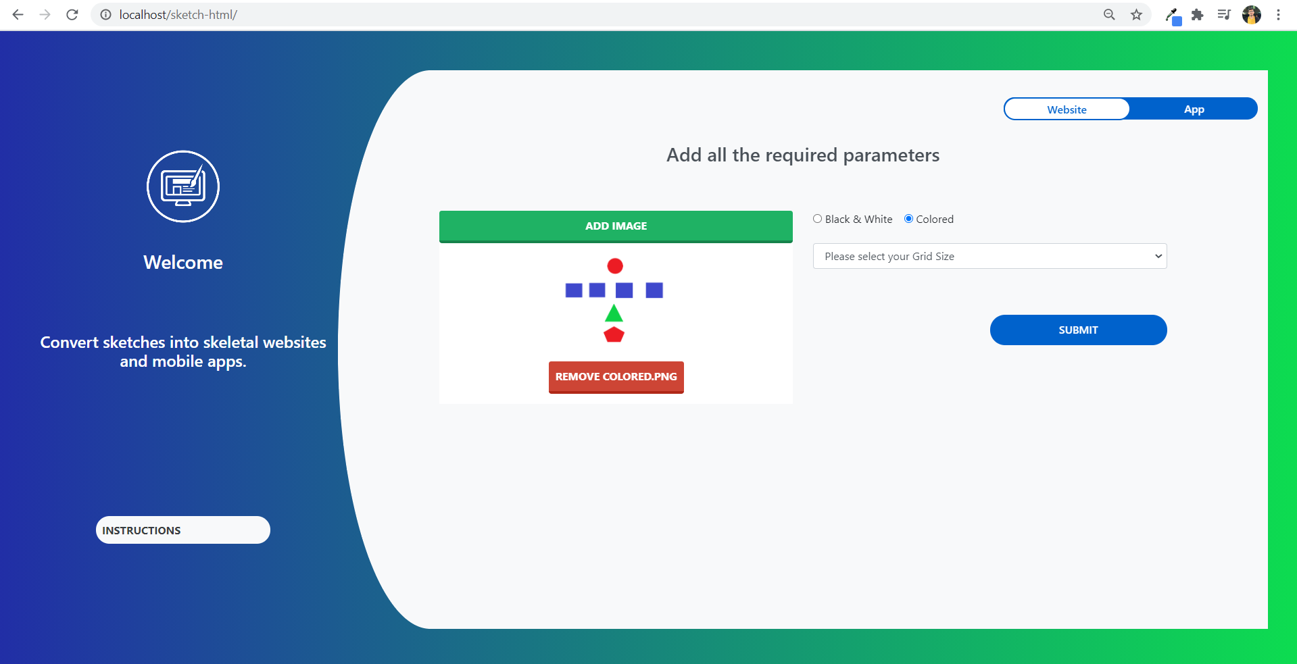](https://mavsuta-my.sharepoint.com/:i:/r/personal/deepbipinbhai_patel_mavs_uta_edu/Documents/CSE6324/Iteration%202/UploadPage.png?csf=1&web=1&e=WVMcjS)**

**D. Customers & Users**

**1. Who are the customers and their needs:**

Our potential customers are teenagers with age ranging from 13-19 and people who don’t have any prior coding experience or people who are into web design.

**2. Customer feedback:**

For the feedbacks we have asked our cousins and friends from India, who are in high school or in first year of their Bachelor’s degree, and importantly they all are someone who share their interest in web design but don’t have any prior experience with the coding.

**E. Reference**

* <https://fronty.com/>
* <https://github.com/ashnkumar/sketch-code>
* <https://pandas.pydata.org/>
* <https://opencv.org/>
* https://blog.expo.io/developing-a-react-native-app-with-expo-cf6566732311